**CENWP-OD-B 01 August 2023**

**MEMORANDUM FOR THE RECORD**

**SUBJECT: 23BON074 MFR WA Shore UMTJ RB1 Lamprey Mortality**

On the morning of 01 August, Project Biologists discovered a Pacific Lamprey mortality in the UMTJ RB#1 (Upstream Migrant Tunnel Junction) of the WA Shore LPS system. The fish was scanned for PIT tags and returned to the river.

1. Species – Pacific Lamprey (*Entosphenus tridentatus*)
2. Origin – Unknown
3. Length – Approximately 64.8 cm.
4. Marks and tags – none
5. Marks and Injuries found on carcass – none
6. Cause and Time of Death –
7. Future and Preventative Measures – none

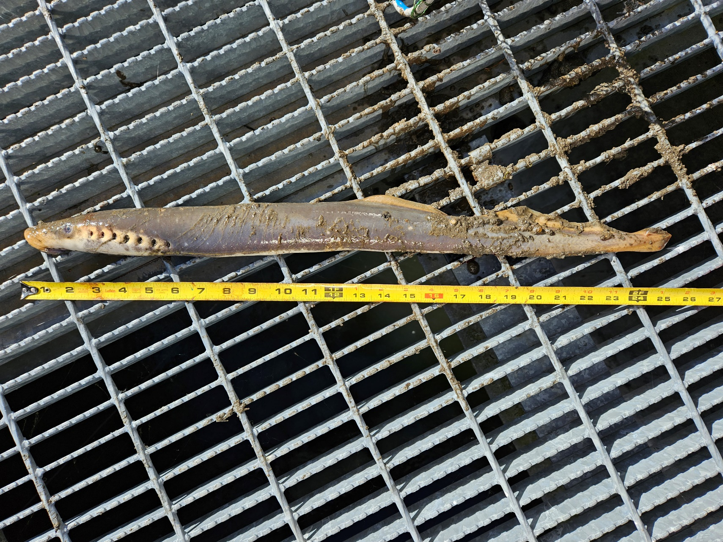

Sincerely,

Bonneville Project Fisheries